PhD Scholar Name:  Institution/research centre Name:  PhD Registration No.:  Date of joining to MAHE PhD program: Date of Protocol approval:  Email Address:  Guide Name and affiliation:  Co-guide/s name and affiliation:  Stream: (please tick)  - Health Sciences (HS)  - Science and Technology (ST)  - Humanities, Liberal arts , Social Science and Management (HLSM)  No. of Original Research Article Publications / Accepted Manuscripts from PhD with candidate as First Author:  Q1 Q2 Q3 Q4  No. of Review Article Publications / Accepted Manuscripts from PhD with candidate as First Author:  Q1 Q2 Q3 Q4  No. of Conference Presentations:  No. of Awards:  No of Copyrights:  Number of Patents:  Number of Book/ Chapters:  Fellowship Received:  Any Grants Received:  Any Other Achievements: | PhD Research Title (as registered with MAHE): Times New Roman, 11 point, bold, sentence case.  Background: Times New Roman, 11-point, sentence case; Maximum 50 words  Objectives: Times New Roman, 11-point, sentence case; Maximum 30 words  Methodology: Times New Roman, 11-point, sentence case; Maximum 100 words  Results of objects completed till date: Times New Roman, 11-point, sentence case; Maximum 100 words.  Conclusion drawn from results: Times New Roman, 12-point, sentence case; Maximum 70 words  Keywords: Maximum 5

*Remove all the instructions highlighted in RED before submission

SIMILARITY INDEX
(The first page of your Turnitin report should look something like this. Your guide must sign on this page, and a scanned copy must be uploaded in the portal)
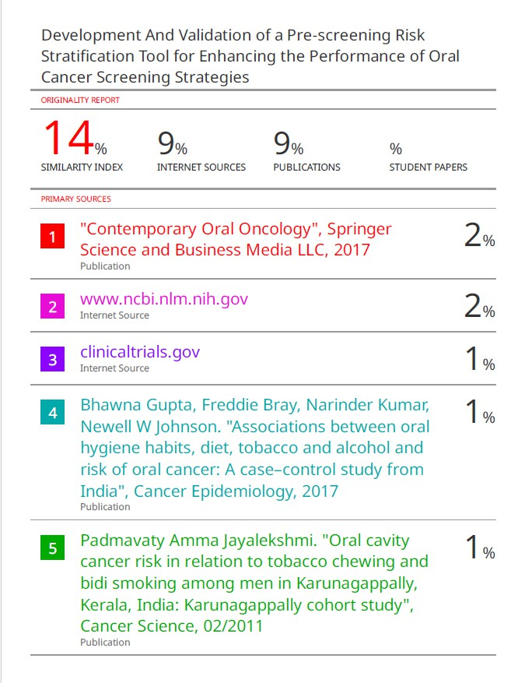

TITLE OF YOUR ABSTRACT

GUIDE’S SIGNATURE: _______________________

